First Eastern & Southern Africa Regional “Thinktank” on Psychosocial Support for Children Affected by AIDS

“Voices for Advocacy on Psychosocial Support for
Children Affected by AIDS”

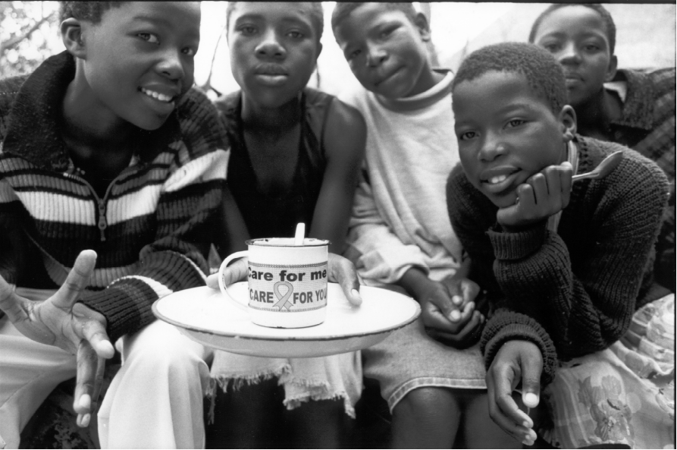

Masiye Camp, Zimbabwe
20-23 August 2001

This call to action is the result of the gathering of 50 participants, coming from 8 countries in Eastern & Southern Africa, representing nongovernmental organisations, institutions of higher learning, church organizations, Southern African Development Community (SADC), UNICEF, UNAIDS, Swiss Agency for Development and Cooperation (SDC) and youth interested in psychosocial support for children affected by AIDS.

Why did we meet?

This meeting started from a concern that many activities supporting children are biased towards the material and formal educational needs of children. There is recognition that many programs in Eastern & Southern Africa supporting vulnerable children, including those affected by AIDS, lack integrated psychosocial support. This “Thinktank” brought together youth, practitioners, academics, donors, representatives from SADC and United Nations agencies to: a) increase the understanding of practical program application of psychosocial support.; and b) find strategies to scale up such responses through a Regional Psychosocial Support Initiative.

In this era of AIDS, children are suffering from poverty, stigma, discrimination, multiple losses, including deaths of family members and friends, and resulting grief. Nevertheless, children represent the hope and opportunity for society. An estimated 13.2 million children have been orphaned by AIDS worldwide since the epidemic begun. Many are struggling to survive, not only in Africa (where the vast majority live), but in developing countries throughout Asia and the Americas.

We believe that for children to realise their full potential, we need to build their strengths and maximise their opportunities. Towards this end, we acknowledge that affected children and youth are often best placed to help meet the psychosocial needs of peers.

We recognise that families, communities, schools, faith-based and other organisations and governments have responsibilities to provide children with psychosocial support in order to enable them enjoy their childhood.

What is psychosocial support?

Psychosocial support is an ongoing process of meeting physical, emotional, social, mental and spiritual needs, all of which are considered essential elements of meaningful and positive human development.

The following wheel represents this model, recognizing that none of these elements are adequate if provided alone.

FamilyCommum
Political Cultural
child
emotional
physical
mental
social
spiritual

Do children affected by AIDS face greater risks?

YES. They face great risk of malnutrition, illness, abuse and sexual exploitation. In addition, the stigma and discrimination so closely associated with AIDS often deprives them of basic social services and education.

What happens if we do not provide psychosocial support?

With the scenario that up to 35% of all children might be orphans in several southern African countries by 2010, failure to support children to overcome such trauma will have very negative impact on society and might cause dysfunctional societies, jeopardizing years of investment in national development.

Continuous traumatic
stress
Syndrome leads to
(Straker 1987)
Crime
Alcohol/Drug abuse
Teenage Pregnancies
Street Children
Chronic Traumatized
Child Prostitution
Violent Behaviour
Severe Depressions
HIV infections

Dysfunctional

Society

How can governments and other organisations become involved?

- By promoting an enabling environment for psychosocial support for children affected by AIDS and other vulnerable children.
- By creating an expanded response by families, communities, governments, faith based and other organisations for psychosocial support for children affected by AIDS and other vulnerable children.

Is psychosocial support a child’s right?

YES. Psychosocial support for children affected by HIV/AIDS is directly linked to the principles of the United Nations Convention on the Rights of the Child (CRC) and the African Charter on the Rights and Welfare of the Child. The CRC recognises that children are vulnerable members of our society. Children affected by AIDS are especially vulnerable to maltreatment or exploitation. Children’s rights to development and protection cannot be realised without psychosocial support.

What action is necessary now?

Every meaningful response to problems vulnerable children face must include an effective psychosocial support component to ensure respect, protection and fulfilment of their rights.

- Promote programs that support orphans and vulnerable children in communities psychologically, economically and socially.
- Build on children’s own resources and peer support wherever it is possible.
- Provide access to education, health and social services for orphans and children.
- Set clear, firm targets to improve the lives and prospects of orphaned and vulnerable children.
- Make a long term commitment to community and human development.

These voices for advocacy on psychosocial support for children affected by AIDS are views of the participants and do not necessarily reflect the respective organisations represented at this “Thinktank”.

This statement is the result of a gathering of individuals belonging to the following organisations:

Terre des Hommes Hululize Tanzania k.madorin@teredeshommes.ch
Salvation Army Masiye masiyeca@telconet.co.zw
Swiss Development Cooperation mokgadi.malahlela@sdc.net
PACT Zimbabwe salmondw@pact.org.zw
Hope Worldwide Edward Phillips@hopeww.org
University of Natal killian@nu.ac.za
FACT, Mutare choice@aloe.co.zw gfoster@syscom.co.zw
FOST, Mutare fostmutare@mango.zw
SCOPE-CARE Zambia siame@care.co.za
Kitovu Home Care and Orphans Programme mmm@africaonline.co.ug
Humuliza Mozambique frcapquel@teledata.mz
Island Hospice island@africaonline.co.zw
Family Support Trust fstrust@mango.zw
University of Zimbabwe rbundy@esanet.zw
Catholic Aids Action, Namibia caa.co-ordinator@ncbc.com.na
Sinoziso Home Care Programme ltowell@iaafrica.com
Nelson Mandela Children’s Fund ShadiX@nmcf.co.za AllyC@nmccf.co.za

Youth from Tsungirirai Program
Youth from Masiye Camp
Youth from Bethany Project
Youth from Kids Clubs

SADC HIV/AIDS Program Manager nzimam@health.gov.za
UNAIDS Inter country team, Pretoria sanderson@un.org.za
UNICEF Zimbabwe fsabatini@unicef.org tmurove@unicef.org

Bibliography

UNAIDS (2001) Together we can – Leadership in a world of AIDS . Document for UNGASS on HIV/AIDS.

UNAIDS (2001) Investing in our Future – Psychosocial Support for Children Affected by AIDS – A Case Study in Tanzania and the United Republic of Tanzania

This „Thinktank“ was made possible by:

-Swiss Agency for Development & Cooperation
-Novartis Foundation for Sustainable Development
-Salvation Army Masiye & Regional Team
-Terre des hommes, Switzerland (Humuliza)
-Pact, Zimbabwe

This publication was made possible by:

-hope hiv contact: info@hopehiv.org

